**Restaurant Output**

* Restaurant website with plane background with simple code

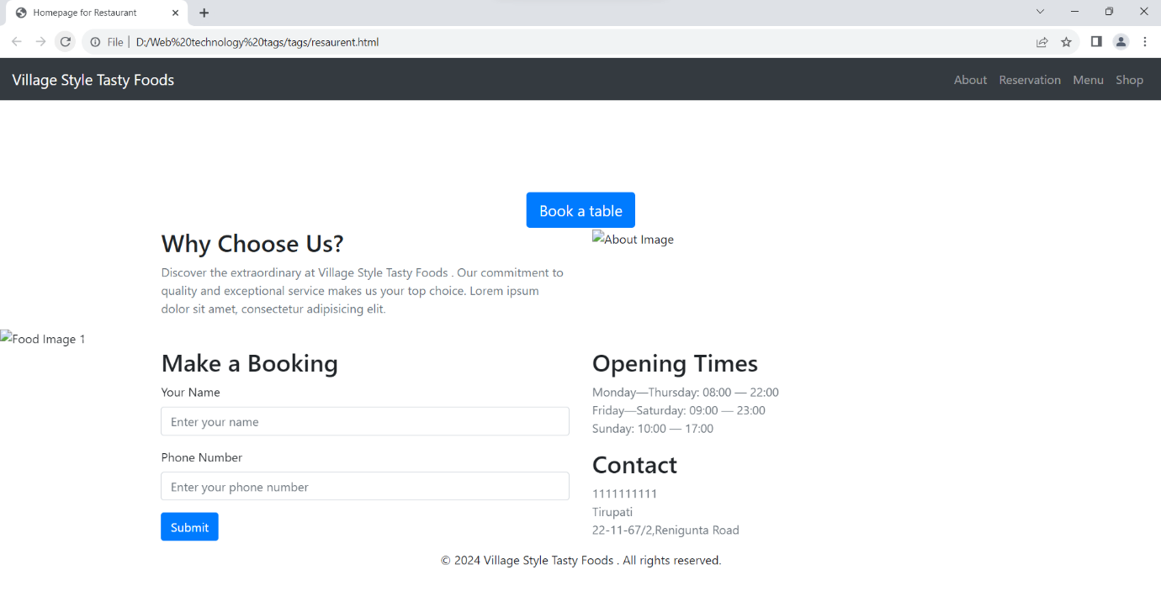

* Restaurant website include with some background and css properties

